Honors Geometry
Transformations Mini-Unit
Section 1: Translations

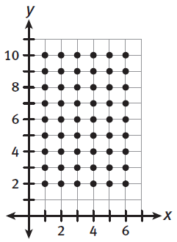
Mr. Scott directs the Marching Cougars, the band at Chavez High School. He used the coordinate plane to represent the football field. For the band’s first show, he arranges the band in a rectangle that is 6 marchers wide and 9 marchers deep.

The band begins by marching down the grid in this formation. Then the marchers
move apart from each other vertically, while keeping the same distance between
marchers within the same row.

The diagrams below show the initial shape of the marchers and the two
transformations that they undergo. To describe and classify the
transformations, compare the pre-image of a transformation to its
image.

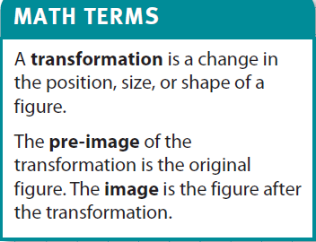
1.) Use your own words to describe Transformation 1.

2.) Compare and contrast Transformation 1 and 2. How are they related? How are they different?

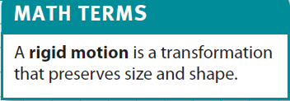
3.) Transformation 1 is an example of a rigid motion. A rigid motion keeps
the same distance between the points that are transformed (in this case, the
marchers of the band); the shape and size of the pre-image and image are the same.

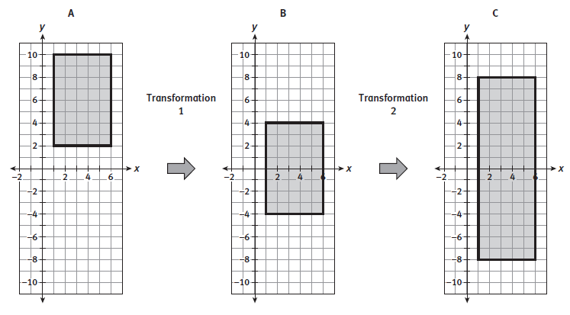
A) How does Transformation 1 affect the distance between any two marchers in the band?

B) How does Transformation 2 affect the distance between the marchers? Is it a rigid motion?

4.) Review Transformation 1. Each point in the pre-image is mapped to a point in the image. For this reason, the transformation can be expressed as a function. (Recall that in a function, each input results in exactly one output.)

A) Complete the table to show the positions of the four corners of the rectangle when Figure A is mapped onto Figure B.

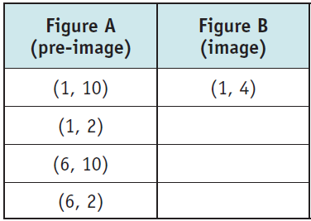

B) For any given point, how does the transformation change the x-coordinate? The y-coordinate?

C) You can use the notation (1, 10) (1, 4) to show how a point is transformed. When you use this notation to show how a general point (x, y) is transformed, you are expressing the transformation as a function. Express Transformation 1 as a function.

5.) Review Transformation 2.
A) Complete the table to show the positions of the four corners of the rectangle when Figure B is mapped onto Figure C.
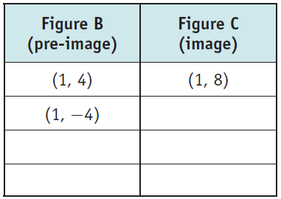

B) For any given point, how does the transformation change the x-coordinate and the y-coordinate?

C) Can Transformation 2 also be expressed as a function? Explain why or why not. Write the function if it exists.

6.) Draw each image on the graph to show how the pre-image is transformed by the function. Then classify the transformation as rigid or non-rigid.

A) (x, y) (x + 3, y)
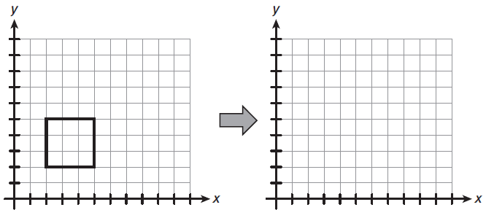

B) (x, y) (2x, 2y)
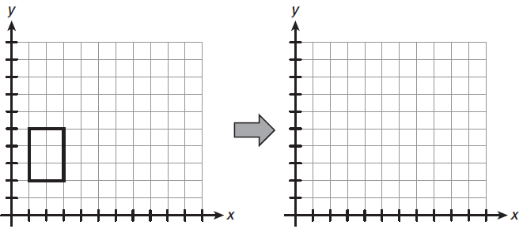

Use the text and diagram to answer Items 7 and 8.
The rectangle undergoes the transformation described by the function (x, y) (x – 2, y + 1).

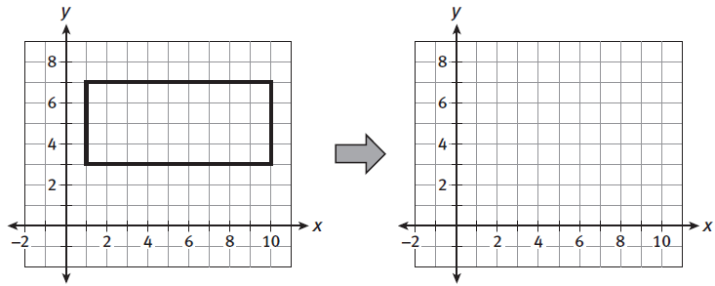

7.) Complete the table to show the coordinates of the image and the pre-image for the four corners of the rectangle.
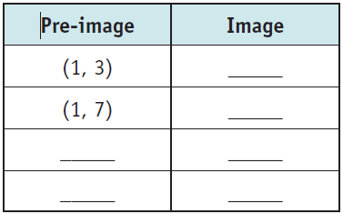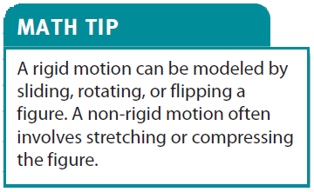

8.) Graph the transformation of the figure. Is the transformation a rigid motion or a non-rigid motion? Explain how you know.

9.) A rectangle is transformed as shown:
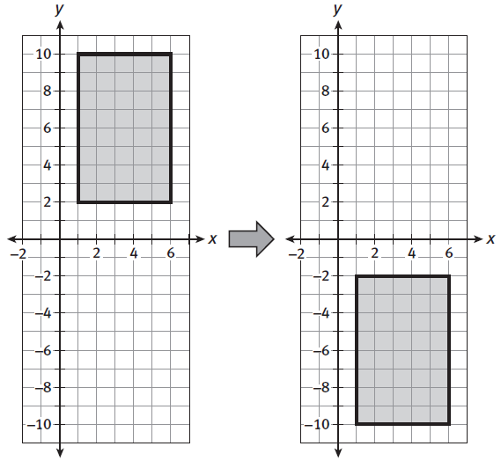

A) Which function describes the transformation?

B) Classify the transformation as rigid or non-rigid. Explain why you classified the transformation that way.
For Items 10 and 11, consider the following: A rectangle undergoes the transformation described by the function
(x, y) (x, y/2).

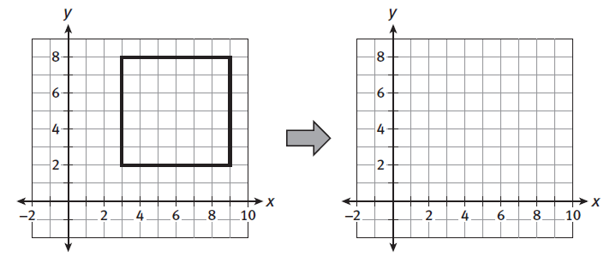

10.) Graph the transformation of the figure. Is the transformation a rigid motion? Explain.

11.) Draw a + sign in the middle of the above image. Describe how the transformation would change the plus sign.

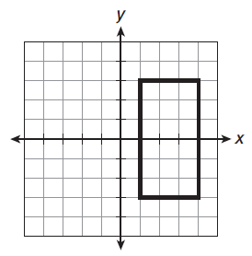
12.) Use the graph of the rectangle to help you classify each
of the following transformations.

A) Draw the image of the rectangle under the transformation
described by the function (x, y) (x/2, y). Classify the
transformation as rigid or non-rigid.

B) Draw the image of the rectangle under the transformation
described by the function (x, y) (x, y + 2). Classify the
transformation as rigid or non-rigid.

Maria marches with the band. At the start of the halftime show, her position is (2, 4) on the coordinate plane. Then Mr. Scott tells everyone to move 2 yards to the right on the field and 4 yards up the field. The band’s transformation is shown in the diagram, and Maria’s position is marked with an X.

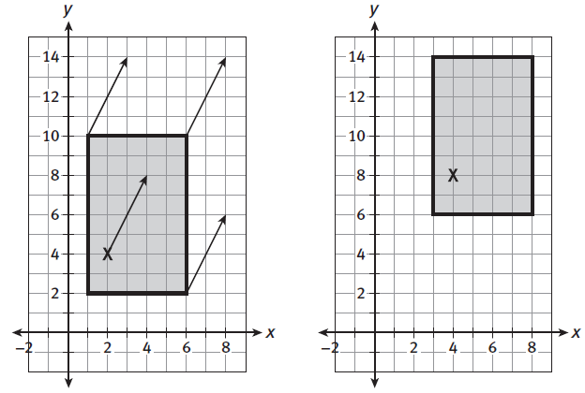

This type of transformation is called a translation. On the coordinate plane, a translation is described by a function of the form (x, y) (x + a, y + b), in which a and b are positive or negative constants. In the example above, a = 2 and b = 4.

You can think of a translation as a figure sliding up or down, left or right, or diagonally. During the translation, every point of the figure moves the same distance and in the same direction. This distance and direction is called a directed line segment. In the diagram, the directed line segment of the translation is shown by each of the arrows.

13.) Complete the table to show how the translation affects for of the Marching Cougars:
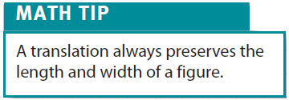
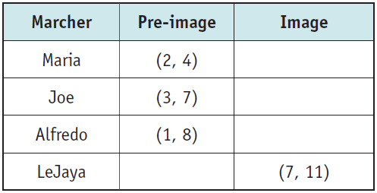

Mr. Scott arranges the band in a rectangle. Then he directs the band member at (6, 10) to move to (4, 13). The numbers on the coordinate plane show yards of the football field:
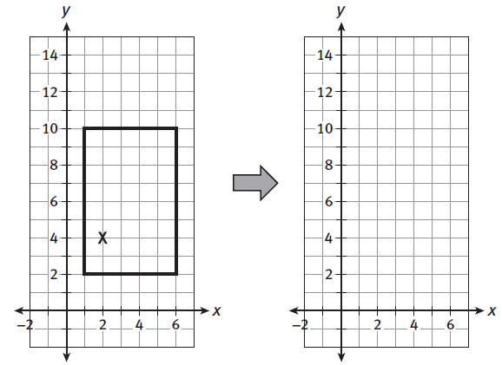

14.) For the band to move in a translation, how should each band member move?

Draw the image of the figure under the translation described by the function.
15.) (x, y) (x + 4, y – 4) 16.) (x, y) (x + 3, y)
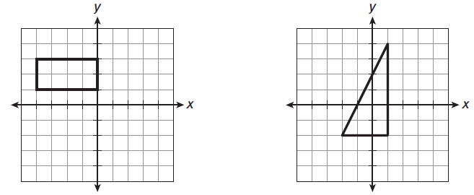

- Translations can also be defined without the coordinate plane. For the directed line segment $\overline{AB}$, a translation maps point P to point P’ (read: “p prime”) so that the following statements are true:
$\overline{PP'}$ is parallel to $\overline{AB}$.
- PP’ = AB
- $\overline{PP'}$ is in the same direction as $\overline{AB}$.

The expression $T_{\overline{AB}}$(P) describes the translation (T) of a given point P by the directed line segment $\overline{AB}$. In the above example, $T_{\overline{AB}}$(P) = P’.

Items 17 through 19 refer to rhombus ABCD shown below. Point P is in the center of the rhombus.

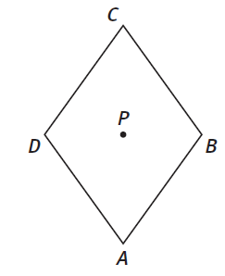

17.) Draw the translation of the rhombus described by the directed line segment $\overline{AB}$. Include P’ = $T_{\overline{AB}}(P)$.

18.) Which part of the rhombus maps onto $\overline{BC}$?

19.) Identify a translation of the rhombus that would map exactly one point of the rhombus onto another point of the rhombus. (Answers may vary.)

20.) Mr. Scott arranges the band in the shape of triangle ABC, shown below. Point P is in the interior of the triangle. He plans three transformations of the triangle in which point P is mapped onto P’, P’’, and P ‘’’ respectively. (Read: “P double prime,” “P triple prime”).

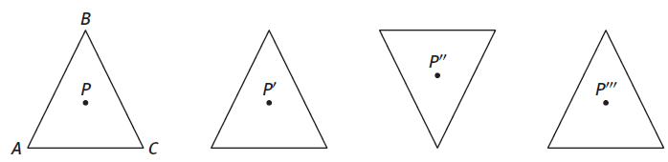

A) Which of the three transformations are translations? Explain your answer by applying the definition of a translation.

B) Maria stands at point P of triangle ABC. To move to point P’, her instructions are to move eight steps to the right. Do these instructions apply to all the other band members? Explain.

The figure below shows hexagon ABCDEF undergoing a translation to the right.
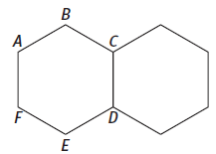
21.) Which part of the pre-image is translated onto $\overline{CD}$?

22.) Express the translation as a function of two points of the hexagon (using a directed line segment).

23.) By repeating this translation many times, you could create a row of hexagons. What additional translation could be repeated to fill the page with hexagons? Is it $T_{\overline{BC}}$, $T_{\overline{BD}}$, or $T_{\overline{BE}}$?

Honors Geometry Name: _______________________________________

Transformations
Section 2: Reflections

Mr. Scott plans another transformation for the Marching Cougars. The sign of the y-coordinate of each marcher changes from positive to negative. Maria, whose position is shown by the X in the diagram, moves from point (2, 4) to the point (2, -4).
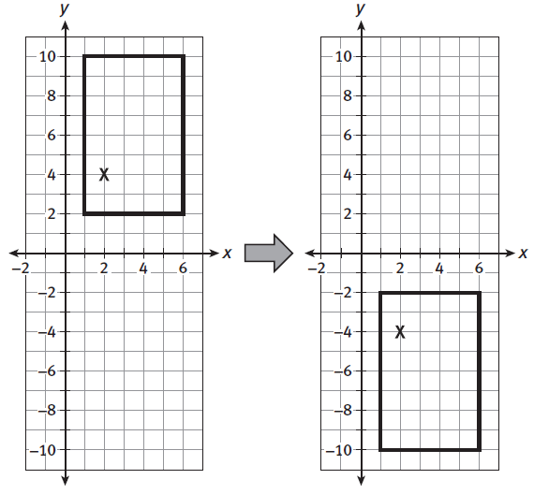
This type of transformation is called a reflection. Reflections are sometimes called flips because the figure is flipped like a pancake. On the coordinate plane, examples of reflections are defined by functions such as (x, y) (-x, y) , which is a reflection across the y-axis. The example shown above is described by (x, y) (x, -y), which is a reflection across the x-axis. The function (x, y) (y, x) defines a reflection across the line y = x.

Every reflection has a line of reflection, which is the line that the reflection maps to itself. In the above diagram, the line of reflection is the x-axis.

1.) Complete the table for the two reflections:

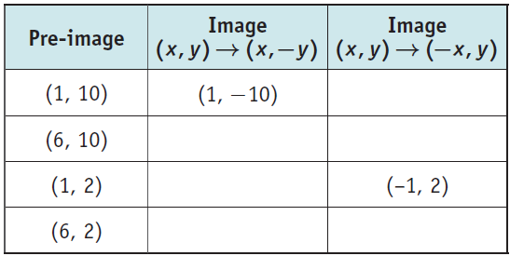

The figure below shows an arrow in the coordinate plane. The tip of the arrow is located at the point (4, 10).
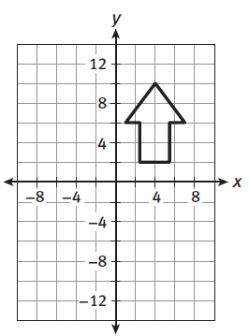
2. Predict the direction of the arrow after these reflections:
A) across the x-axis
B) across the y-axis

3.) Draw the two reflections described in the previous question. Were your predictions correct?

4.) What reflection maps the arrow to a downward arrow that also has its tip at the point (4, 10)?

5.) Could a reflection map the arrow so it points to the right or to the left (i.e. parallel or to the x-axis)? If yes, describe the line of reflection.
Mr. Scott arranges the tuba players in an arrow formation, shown below. Then the tuba players undergo a reflection that is described by the function (x, y) (8 – x, y).
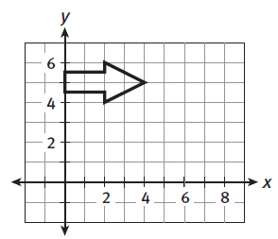

6.) Draw the reflection. Identify the line of reflection.

7.) Which tuba players travel the longest distance during the reflection? Identify this distance.

8.) Which tuba player does not travel any distance during the reflection?

9.) Explain why the reflection does not change the distance between any given tuba player and the point (4, 5).

10.) What happens to any point that lies on the line of reflection?

Like other transformations, reflections can be defined independently of the coordinate plane. A reflection is a transformation that maps P to P’ across line l such that:
- If P is not on l, then L is the perpendicular bisector of $\overline{PP'}$
- If P is on l, then P = P’

To describe reflections, we will use the notation $R_{l}\left(P\right)=P'$, in which $R_{l}$ is the function that maps point P to P’ across line l, the line of reflection.

11. The diagram shows pentagon ABCDE and the reflection $R_{l}$.
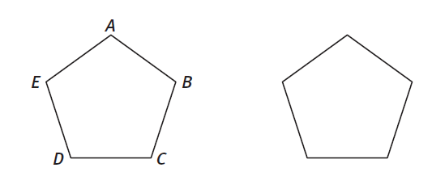

A) Draw line l.

B) Label the points $R_{l}\left(A\right)=A^{'}$, $R_{l}\left(B\right)=B'$, and so on for the five vertices.

Look at quadrilateral ABCD. It was constructed by the reflection of a figure, which means that it has reflectional symmetry. Line segment BC is the line of symmetry of the figure. A line of symmetry can be an actual line in the figure, or it may be imaginary. A figure may have any number of lines of symmetry, including an infinite number.
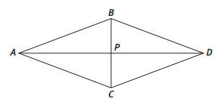
12.) For each figure shown below, draw all of the lines of symmetry.

13.) Triangle ABC has three lines of symmetry, labeled l₁, l₂, and l₃ in the figure below. What can you conclude about the triangle? Explain.

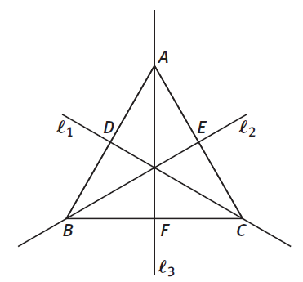
The figure below shows the scalene triangle ABC, which by definition has three unequal sides. Point D is on $\overline{AC}$, and $\overline{BD}$ is perpendicular to $\overline{AC}$.
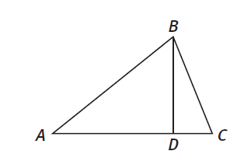

14.) Explain why $\overline{BD}$ is not a line of symmetry for the triangle.

15.) Does triangle ABC have any lines of symmetry? Explain.

Use the figure for Items 16 and 17.
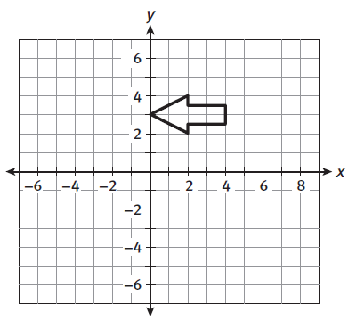

16. Draw the reflection of the arrow described by each of these functions, and identify the line of reflection.
A) (x, y) (8 – x, y)

B) (x, y) (-2 – x, y)

C) (x, y) (x, -y)

17.) Describe a reflection that would map the arrow onto itself.

18.) Irregular pentagon ABCDE has exactly one line of symmetry, which passes through point A.

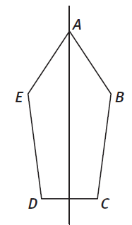

19.) What is the image of point C under a reflection across the line of symmetry?

20.) Does any point remain fixed under a reflection across the line of symmetry? Explain.

21.) Which sides of the pentagon must be congruent?

Honors Geometry Name: _________________________________

Transformations
Section 3: Rotations

For the big finish of the Marching Cougars’ performance, Mr. Scott arranges the band in a triangle formation. Then the triangle appears to rotate clockwise around a point, like a pinwheel. The center of the rotation is the vertex located at (0, 0) on the coordinate plane.

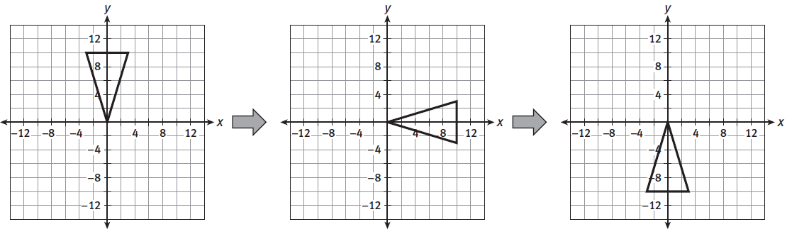

This spinning type of transformation is called a rotation. It is defined by the center of the rotation, which is mapped to itself, and the angle of the rotation.

The center of rotation may be part of the figure being rotated, as is the case shown above. Or it may be a point outside the figure.

Functions that describe rotations include (x, y) (y, -x), which is a clockwise rotation of 90⁰. Repeat the function twice to produce (x, y) (-x, -y), which is a rotation of 180⁰. The function (x, y) (-y, x) is a clockwise rotation of 270⁰, or 90⁰ counterclockwise.

1.) Complete the table for the two rotations shown above.
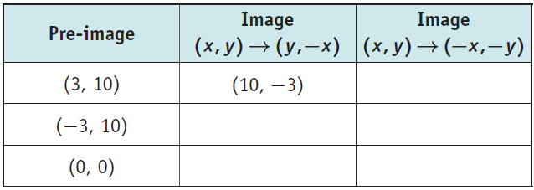

Use the figure for Items 2 and 3.
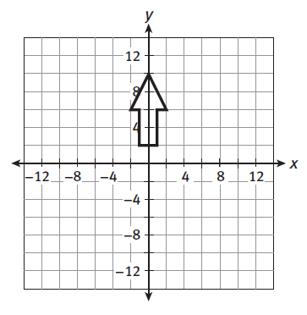

2. Predict the direction of the arrow after these rotations. Assume the center of rotation is (0, 0).
A) 90 degrees clockwise
B) 180 degrees
C) 90 degrees counterclockwise

3.) Draw the three rotations. Were your predictions correct?

4.) Describe the rotation that maps figure A onto figure B. (Hint: First identify the center of rotation.)
A) 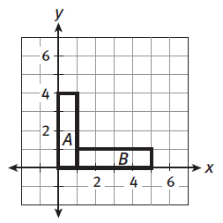 B) 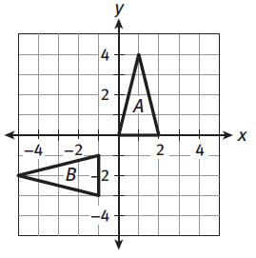

The angle of rotation can be used to describe the image of every point of the figure. Consider the rotation shown below. Rectangle ABCO is rotated 90⁰ clockwise, and maps onto rectangle A’B’C’O. From the diagram, it appears that $\overline{AO}⊥\overline{A'O}$ and that $\overline{CO}⊥\overline{C'O}$. If you measure $∠BOB'$, you will find that it, too, equals 90⁰.
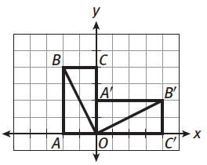

The following figure is a square that is centered around the origin O. Point A is one vertex of the square.
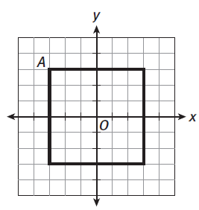

5.) Draw a rotation of the square 45⁰ clockwise about the origin. Label the point A’ that is the image of point A.

6.) What is the measure of $∠AOA'$?
Like translations and reflections, rotations can be defined independently of the coordinate plane. A rotation that maps P to P’ and Q to Q’ has the following properties. Let point O be the center of rotation.
- PO = P’O, and QO = Q’O
- $∠POP^{'}≅∠QOQ'$
To describe rotations, we will use the notation $R_{O, m°}\left(P\right)=P'$ in which $R_{O, m°}$ is the function that maps point P to P’ with center of rotation at point O and through an angle of m⁰.

7.) The diagram shows isosceles triangle ABC, and point O inside it. Draw the following rotations. Label the images of the three vertices.

- $R_{O, -90°}$ B.) $R_{C, 90°}$ C.) $R_{A, 90°}$

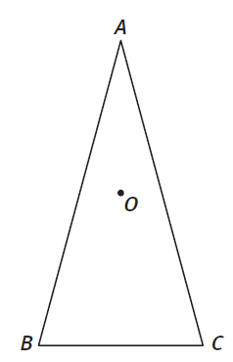

8.) Describe three rotations that each map a square onto itself.

Review your answer to Item 8. Figures such as squares have rotational symmetry, meaning that a rotation of less than 360⁰ can map the shape onto itself. The smallest such angle is the angle of rotational symmetry.

9. Identify whether these figures have rotational symmetry, reflectional symmetry, or both. Also identify the angles of rotational symmetry and lines of reflectional symmetry.

A) Isosceles Triangle B) Equilateral Triangle C) Rhombus
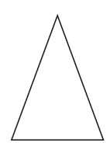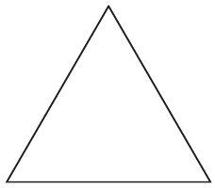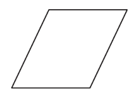

D) Regular Hexagon

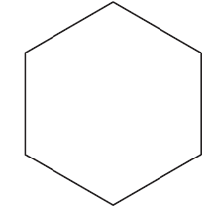

10.) The figure shows parallelogram ABCD (shaded) and its rotation.

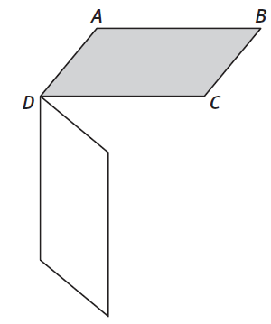
A) Name the rotation.
B) Label the vertices A’, B’, and C’ of the rotated figure.

C) If $∠ADC=30°$, find $∠A'DC$

11. Identify an example of a figure that meets these sets of properties:

A) rotational symmetry with angle of rotational symmetry of 90⁰

B) rotational symmetry with angles of rotational symmetry of 72⁰

C) rotational symmetry with angle of rotational symmetry of 180⁰, two
lines of reflectional symmetry.

D) rotational symmetry with angle of rotational symmetry of 180⁰, no
lines of reflectional symmetry.
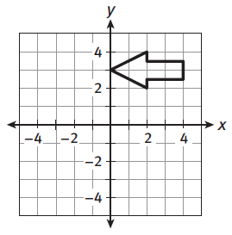
12. Describe the rotation that would move the arrow (shown to the right)
to these positions:

A) Pointing up, with the tip at (4, 7)

B) Pointing down, with the tip at (0, 3)

C) Pointing up, with the tip at (3, 0)

13. Identify the direction of the arrow and the position of the tip after
these rotations.

A) 90⁰ counterclockwise about (4, 3)

B) 180⁰ about (2, 3)

C) 90⁰ clockwise about (2, 0)

14.) Describe a figure that has an angle of rotational symmetry of 10⁰.

15.) Do you think it would be possible for a figure to have an angle of rotational symmetry of 37⁰? If so, describe the figure. If not, explain why not.

