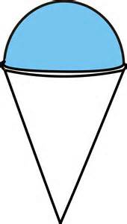
Composite Solids
Find the volume of the figure below. Leave $π$ in your answer.
The height of the cone is 9 in and the radius is 5 in.

$$approx. 158.33π in^{3}$$

Find the volume of the figure below. Leave $π$ in your answer.
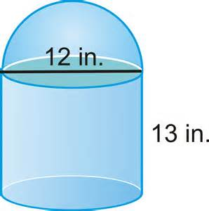 $612π in^{3}$

Find the volume of the figure below. Leave $π$ in your answer.
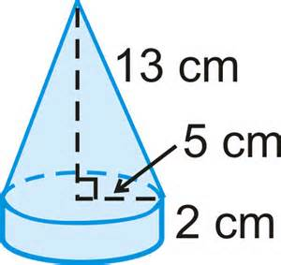 $approx. 158.33π cm^{3}$
How much empty space is left in the figure below? Leave $π$ in your answer.
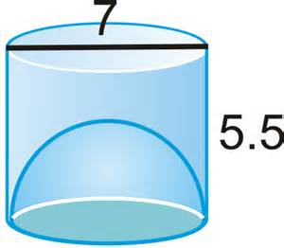 $approx. 38.795π$

